Exchange Rates Board Set Software
·To run the software ,you need .Net Framework 4.0 installed.

1、Start Window:
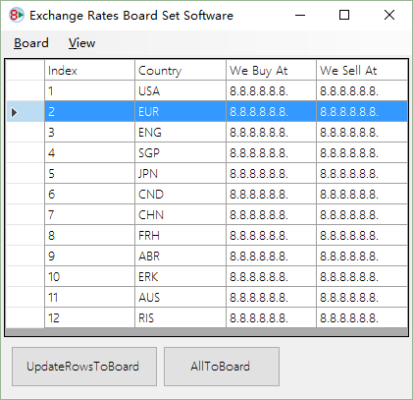
To match the board view, you need add or delete row from the Board menu,
Some board may need add column, set the right datas format to match the board then it works right.

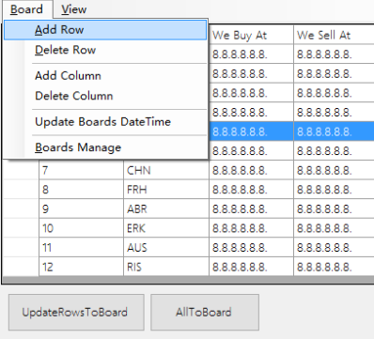
2、Add Board(s) from menu Board/Boards Manage：

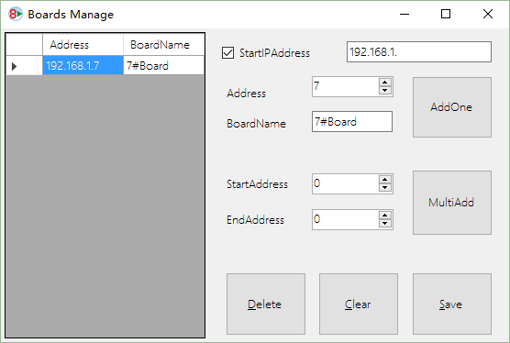
A IP Address such as “192.168.1.7” is combine with:
StartIPAddress like “192.168.1.” and Address from 0~255,
BoardName is a name of the board set if needed.
Click AddOne To Add a board,
or Click MultiAdd to add a serial boards from StartAddress to EndAddress.

You can Delete a selected row or Clear all.
After all Click Save button to save boards settings.

3、Click UpdateRowsToBoard or AllToBoard to update selected rows or all to the board(s)
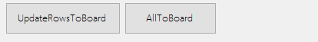
4、When you click , a select board window form will appear,you can select the board you want to set the values. Some like below:
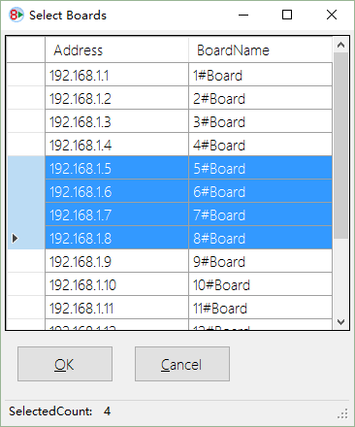

5、Click OK to update values~.

